

**Signals and Systems**

Lab Report#11

# Name:

Taha Saeed

**Registration number:**

FA18-EEE-032

**Submitted to:**

Dr. Ghufran Shafiq

# In-Lab Tasks

#### **Task-1**

Compute the Fourier transform of . MATLAB code is given in following, run this code and compare your output using eq. (11.3). Write your code and results in following.

**Solution:**

clear all;

clc;

syms t w

x=exp(-t.^2);

X=fourier(x,w)

X1=int(x.*exp(-1i*w*t),t,-inf,inf)

**Result:**

X = pi^(1/2)/exp(w^2/4)

X1 =pi^(1/2)/exp(w^2/4)

As can be seen from the above result that the answer of built in Fourier transform function and equation (11.3) is same.

#### **Task-2**

Compute the inverse Fourier transform of X = exp(-1/4*w^2)*pi^(1/2) using the command for inverse Fourier transform and also verify your result using eq. (11.7). Give your results in following.

**Solution:**

clear all;

clc;

syms t w

X = (exp(-1/4.*w^2))*pi^(1/2);

x1 = ifourier(X,t);

subplot(2,1,1);

ezplot(x1,[-5,5]);

ylim([-2 2]);

x2=(1/(2*pi)).*int(X.*exp(1i*w*t),w,-inf,inf);

subplot(2,1,2);

ezplot(x2,[-5,5]);

ylim([-2 2]);

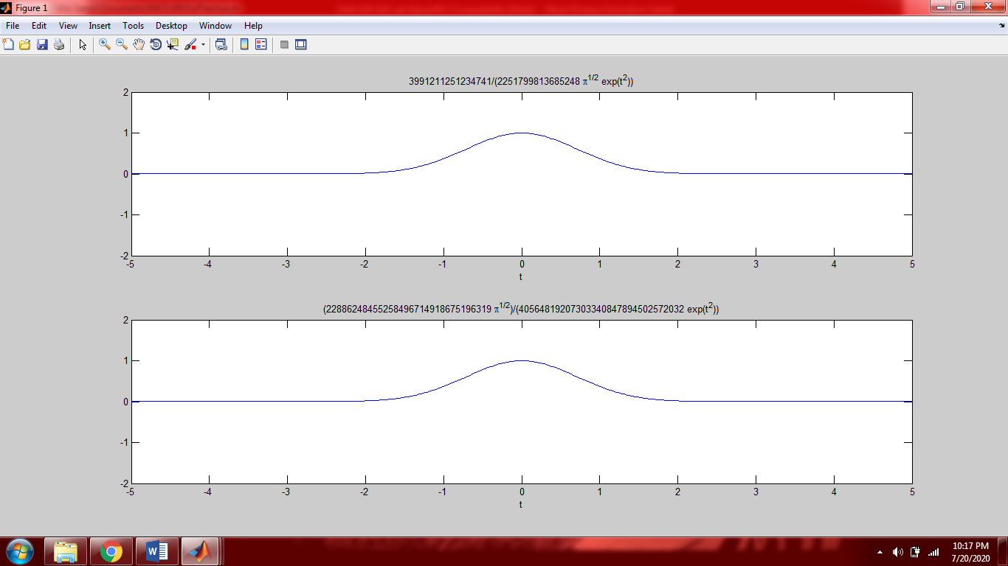

**Result:**

As can be seen from the above figure that both graphs are same. Hence built in function of inverse Fourier transform and equation (11.7) gives same answer.

#### **Task-3**

Compute the inverse Fourier transform of the function *X* () 1**/** (1  *j*) using command of Fourier and then take inverse of the resultant x(t) to produce again *X* ().

**Solution:**

clear all;

clc;

syms t w

x=1/(1+1i*w);

X=ifourier(x,t);

X1=fourier(X,w)

**Result:**

X1 =1/(1 + w*i)

X1 is the same as *X* ()

#### **Task-4**

Let x(t) = 1, compute its Fourier transform to produce X(w) and then take inverse Fourier transform of X(w) to get back x(t), using commands of Fourier transform.

**Solution:**

clear all;

clc;

syms t w

x=1;

X=fourier(x,w);

X1=ifourier(X,t)

**Result:**

X1 =1

X1= x(t) = 1

#### **Task-5**

Let x(t) = u(t), compute its Fourier transform, take inverse Fourier transform of the resultant signal to get back x(t).

**Solution:**

clear all;

clc;

syms t w

x=heaviside(t);

figure(1);

ezplot(x,[-1,5]);

X=fourier(x,w);

X1=ifourier(X,t);

X1=vpa(X1)

figure(2)

ezplot(X1,[-1,5]);

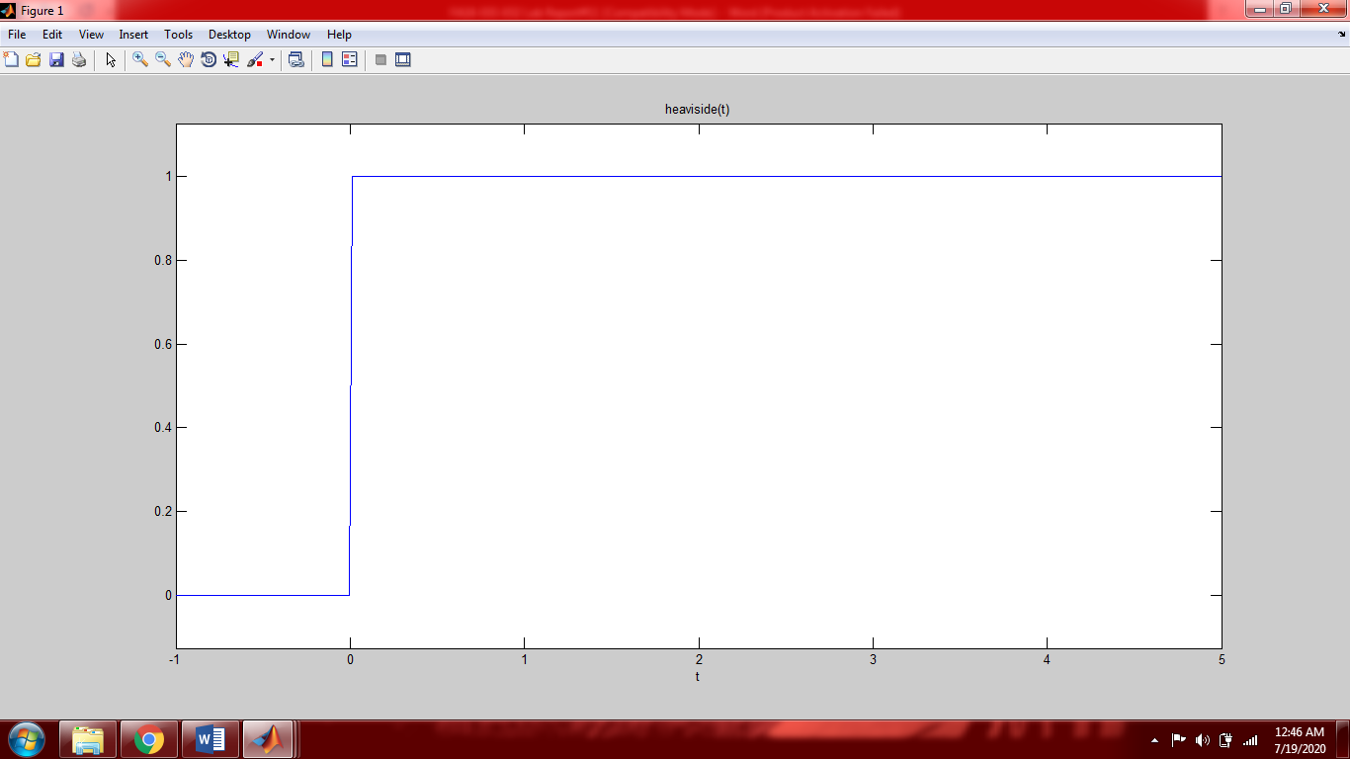

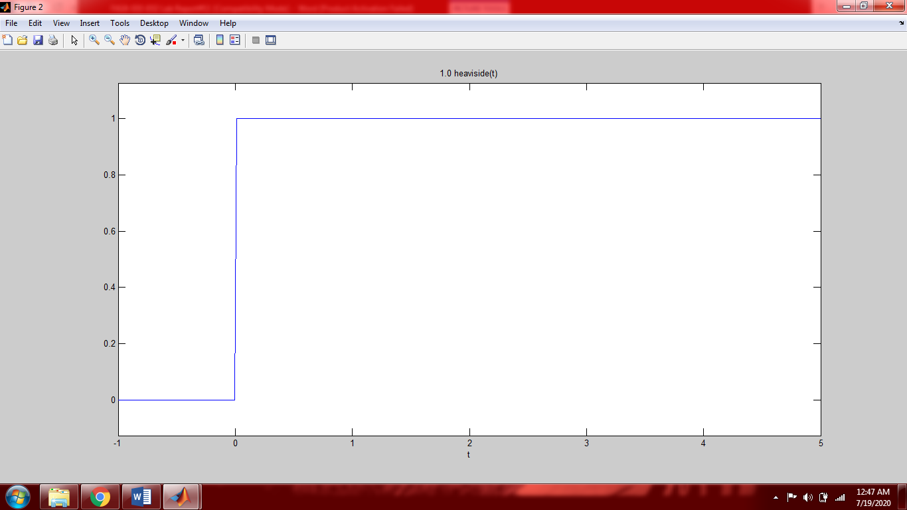

#### **Result:**

X1 =1.0*heaviside(t)

X1= x(t) = u(t). It can also be seen from the graphs that we got back our original signal

#### **Task-6**

Let x(t) = , compute its Fourier transform, take inverse Fourier transform of the resultant signal and state whether it is possible to get back x(t) or not?

**Solution:**

clear all;

clc;

syms t w

x=diff(heaviside(t),t);

X=fourier(x,w);

X1=ifourier(X,t);

X1=vpa(X1)

**Result:**

X1 =1.0*dirac(t)

X1= x(t) =

#### **Task-7**

Prove that and X are Fourier transform pairs of each other.

**Solution:**

clear all;

clc;

syms t w

x=diff(heaviside(t-2));

X=fourier(x,w)

x1=exp(-1i*2*w);

X1=ifourier(x1,t);

X1=vpa(X1)

**Result:**

X =1/exp(2*w*i)

X1 =1.0*dirac(t - 2.0)

Hence proved that and X are Fourier transform pairs of each other.

#### **Task-8**

Prove that and X are Fourier transform pairs of each other.

**Solution:**

clear all;

clc;

syms t w

x=heaviside(t-2);

X=fourier(x,w);

X=vpa(X)

x1=exp(-2*1i*w)*(pi*dirac(w)-1i/w);

X1=ifourier(X,t);

X1=vpa(X1)

**Result:**

X =1.0*(1/exp(2.0*w*i))*(3.1415926535897932384626433832795*dirac(w) - (1.0*i)/w)

X1 =1.0*heaviside(t - 2.0)

Hence proved that and X are Fourier transform pairs of each other.

**Post-Lab Task**

## Critical Analysis / Conclusion

|  |
| --- |
| In this lab we took Fourier transform and inverse Fourier transform of different functions. Fourier transform is used to transform a time domain signal into frequency domain because frequency domain givers more information as compared to time domain. In this lab we used built in commands to find Fourier transform and inverse Fourier transform. We also used formula of Fourier transform eq (11.3) and inverse Fourier transform eq (11.7). The formulas and built in commands gave the same answer. The built in commands are much easier and faster to use as compared to formula. |